Software engineering for big data analaysis

CSA-1035

EXP NO:- 20

20. Draw an Activity diagram for Hospital Management System using CASE tools with Familiarizing activity Diagram Components, parts that are used to make the diagrams which determine the targeted users. Analyse the activities included plot of Hospital, Patient, Doctor, Receptionist the relationship. Show how the user, the hospital staff, can interact with the system model.

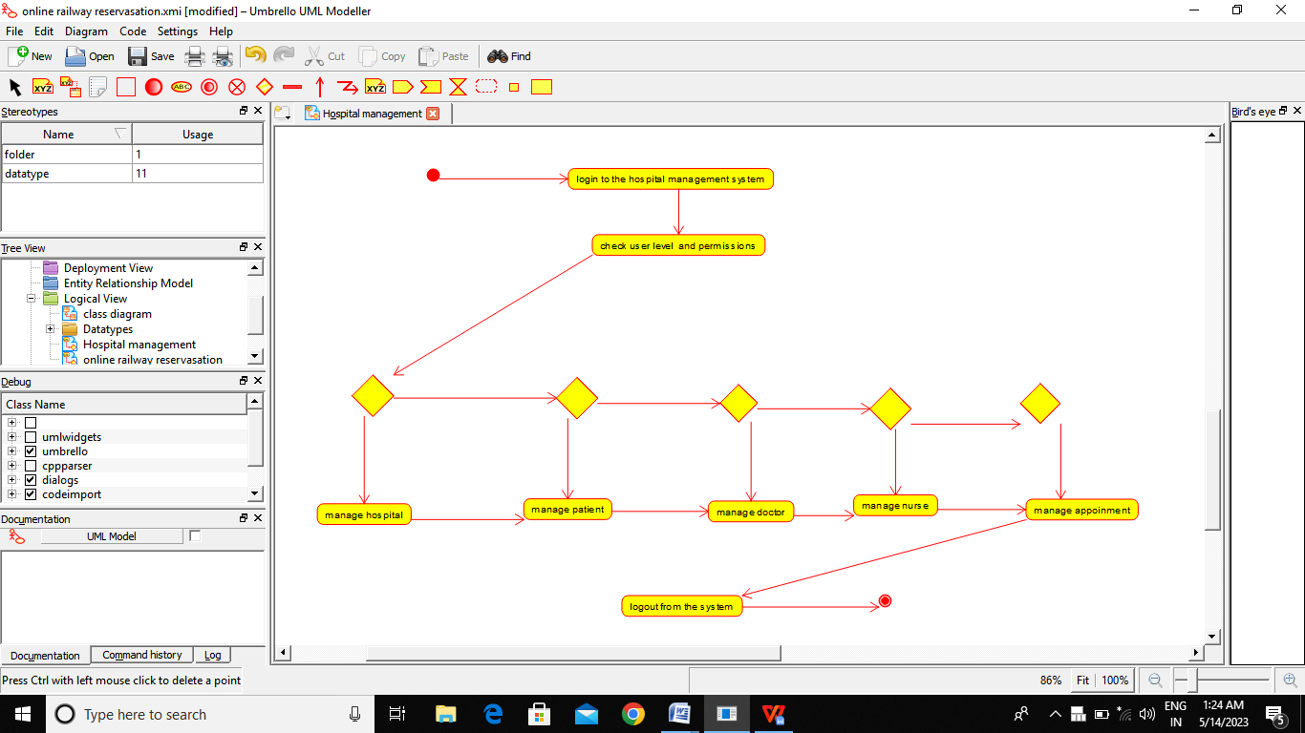

RESULT:-

Thus the Activity diagram for Hospital management is drawn and verified successfully